Chapter 8 Capital Budgeting Cash Flows

Requirements
Calculation:
Incremental Cash Flow: initial investment, operating cash flow, terminal cash flow. Depreciation, book value of fixed asset, after-tax proceeds from sale
Understanding:
Sunk Cost, Opportunity Cost, Mutually Exclusive Projects, Independent projects, Non-conventional Cash Flow, Capital Rationing

1. Basic Terminology
1) Definition
Capital Budgeting is to identify, evaluate, and implement a firm’s long-term investment opportunities. A long-term project will operate in more than one year, and usually involve a large amount of up-front investment followed by a series of smaller cash inflows as it starts to bring in revenues. The valuation of a project such as opening a new factory, producing a new product, or acquiring a company, is a process of capital budgeting.
Capital budgeting decisions can be the most complex decisions facing management. A poor management on capital budgeting can ultimately lead a company to bankruptcy.
Examples of Capital Budgeting Decisions are:
- Expand an existing product line
- Working capital
- Refunding
- Leasing
- Merger and acquisition
- Enter a new line of business
- Replacement
- Advertising campaign
- R&D
- Education and training
2) Two types of projects
Mutually Exclusive Projects are investments that compete with one another for resources such as fixed assets and human resources. Acceptance of one automatically rejects the others.
Suppose Citigroup Corporation has an unused commercial building at Brookhaven, they can either sell it or rent it. But Citigroup CAN NOT take both choices at the same time, for they are mutually exclusive.
Independent Projects: Accept or reject one project will have no effect on others. If all of the independent projects are profitable, they can be taken at the same time. For example, Citigroup can open a new branch in Oakdale, Long Island; meanwhile acquire the branch of Chase Bank Corporation at Smithtown.
All the projects, regardless their types, are competing for the limited funding within a firm. When the company does not have enough money to invest in ALL of the profitable projects, it needs to choose the best set of projects that maximizes the company’s total value. This selection process is known as ‘Capital rationing’.

3) Two types of cash flows
Conventional Cash Flow Projects are the projects that have cash expenses (net cash outflows) at the beginning time, and then turn to cash profits (net cash inflows) afterward.
Nonconventional Cash Flow Projects are the special type of projects that requires continuous investments during the operation years of projects. For example, it will cost a large amount of money to end a nuclear power plant project. A non-conventional project could have negative cash flows both at the beginning of the project as well as during the middle or ending years of the project.
The following two cash flow graphs illustrate the difference between a conventional cash flow project and a non-conventional one.
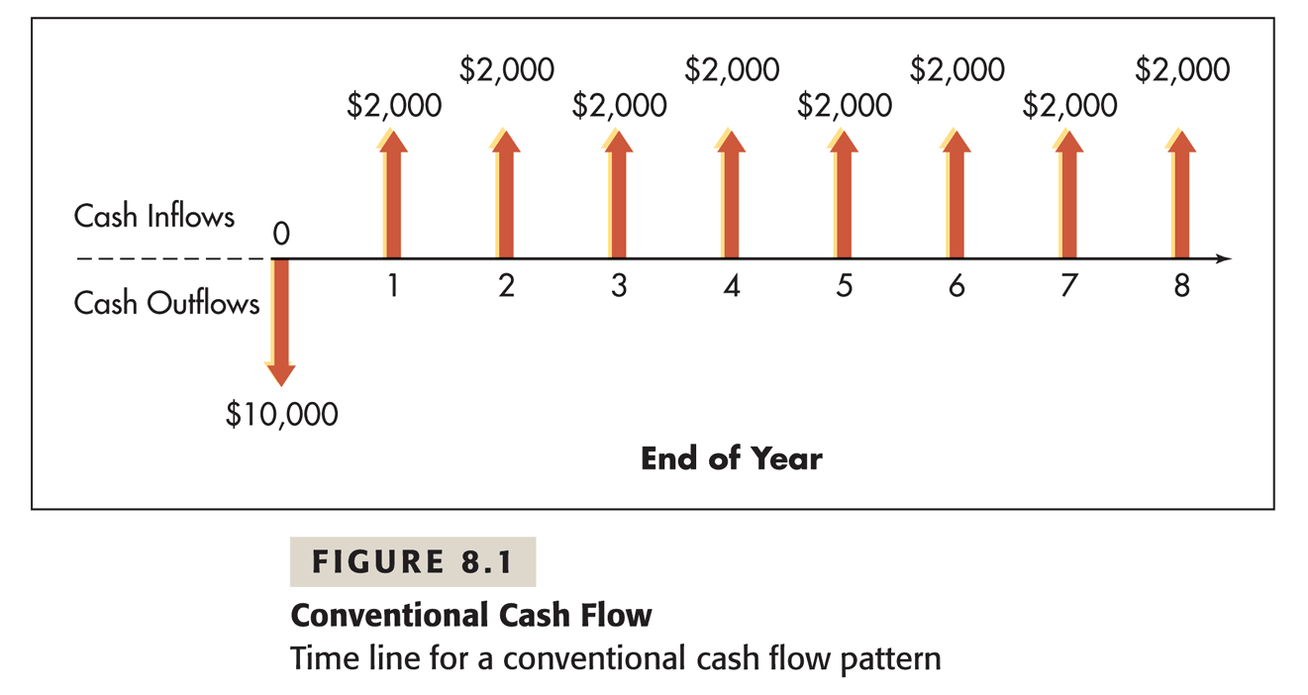

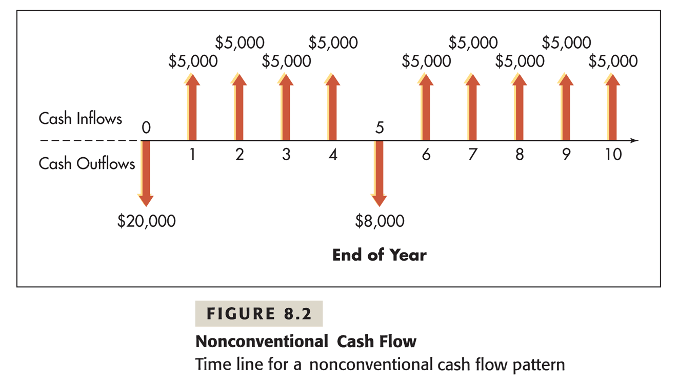

2. Steps in capital budgeting
- Recognize and calculate the incremental cash flows
- Find out the cost of capital (including equity capital and debt capital) in the firm
- Evaluate each project
- Select projects
Step 1 is covered in this chapter; step 3 and 4 will be illustrated in the next chapter; and step 2 will be discussed in Chapter 11.

3. Recognize Incremental Cash Flows:
The first step in capital budgeting is to isolate the cash flows that are created by or directly related to the project from those irrelevant. These cash flows are called incremental. An incremental cash flow must meet two conditions: 1) it is project related; 2) it occurs AFTER the investment decision has been made.
The easiest way to determine whether a cash flow item is incremental is by asking two questions:
- What will this cash flow be with the project?
- What will this cash flow be without the project?
If you find the answers to the two questions are different, this cash flow item is incremental; otherwise, it is irrelevant.

1) Cash flows that are NOT incremental:
- Sunk cost
Sunk costs are the cash outlays made BEFORE an investment decision is made. The money will need to be spent no matter whether the project will be taken or not. For example, the cost of test marketing, or the research expenses on a possible project, etc. These costs or expenses can not be retrieved even when projects are rejected.
- Interest expenses
Capital budgeting technique separates a financial decision from an investment decision. The amount of Interest payment needed is determined by the company’s financial status and financing plans. So, interest payment will be considered in financial decisions, and NOT in the calculation of incremental cash flows in making investment decisions.
As a component of financial cost, interest payment in percentage will be discussed and included later in the calculation of a company’s cost of capital. Cost of capital is often used as the required rate of return in project valuation.

2) Which items belong to incremental cash flows?
- Basic types
- Investments in Related fixed assets (buildings, land, machinery, etc.),
- Investments in Related net working capital (cash, account receivables, inventories, account payables, etc.)
- Revenues received, or costs/expenses made for the project
- All incremental cash flows should be measured on after-tax basis
- Special types
- Deprecations of the related fixed assets
- Opportunity costs
- Indirect effects (or externality)

- The deprecations of the fixed assets newly purchased for the project (pgs 104- 106 in Chapter 3)
Depreciation is an accounting method to amortize the cost of a fixed asset which was purchased before, over the whole life of the asset. Annual depreciation is recorded in income statement as a non-cash expense to match revenue with costs; the cumulated depreciation is recorded on balance sheet under the gross value of fixed assets, in order to get the net fixed asset value.
Although it is NOT a cash expenses, it provides a role in tax deduction. The higher the value of annual depreciation, the more tax deductions can be taken, and less taxes have to be paid. This brings up the value of operating cash flow. Due to its tax benefit, depreciation is a very important component in cash flow calculation.
There are various methods of taking depreciation in accounting practice. The most common one is the modified accelerated cost recovery system (MACRS).
Annual depreciation = total cost of fixed cost * depreciation percentage
Example:
A machine just purchased cost $150,000, and has a life of 6 years. If using the MACRS of a 5-year recovery schedule, what is it’s annual deprecation?
Year | Total Cost | * % Depreciation | = Annual Depreciation
1 | $ 150,000 | 20% | $ 30,000
2 | $ 150,000 | 32%
3 | $ 150,000 | 19%
4 | $ 150,000 | 12%
5 | $ 150,000 | 12%
6 | $ 150,000 | 5%

- Opportunity cost
When you spent money to buy a car, you automatically lost the chance of using that money to make other investments. The highest value you would have gained from the alternative choices is deemed as a cost, named ‘opportunity cost’ to your car purchase decision.
Suppose you want to invest in real estate, but only have money to buy one of the three residential buildings: building A is in Long Island, B in Queens, and C in Manhattan. The net gain of each is $40,000 for A, $37,000 for B, and $61,000 for C. If you invest in building C in Manhattan, what will be the dollar amount of your opportunity cost? Which one of the following answers is correct?
- $40,000
- $37,000
- $61,000
The answer is a. It means when you choose building C, you are giving up the possible gains from building A and B, for you can only afford one building. The maximum amount of dollars you are losing the chance to earn is $40,000. Why b is not the answer, because it underestimates your potential cost.
In capital budgeting, the value of resources (ex. land, equipments) used in a project should be measured by their opportunity costs.

- Indirect (External) effect
Externality is the side effect of an economy activity. It shows how a business or project will affect a society and its population. Externality can be good or bad. Chemical pollutants from a pharmaceutical factory have a bad externality to its community. A new opened campus of Columbia University in Long Island area has a positive externality, since local population can have more education choices now.
When the externality of a project can be measured by dollar amount, its benefit or cost shall be considered in project valuation.

- For a (machinery) replacement project, incremental cash flows equal to :
Cash flows with the new project
Minus Cash flow without the new project.

4. Incremental cash flow calculation
After the recognition of cash flows, we should sum up all the incremental cash amounts within each of the future years, and discount the sums to the present time to get the total present value of a project.
The following table is a worksheet of incremental cash flow calculation.
 | Year 0 | Year 1 | Year 2 | … | Year N-1 | Year N
 | the beginning of the project | the operating years |  |  |  | the ending of the project
Cash Flow | $ | $ | $ | $... | $ | $
PV

Basic Formulae
At year 0: NINV (initial investment) -- the initial net cash outlay.
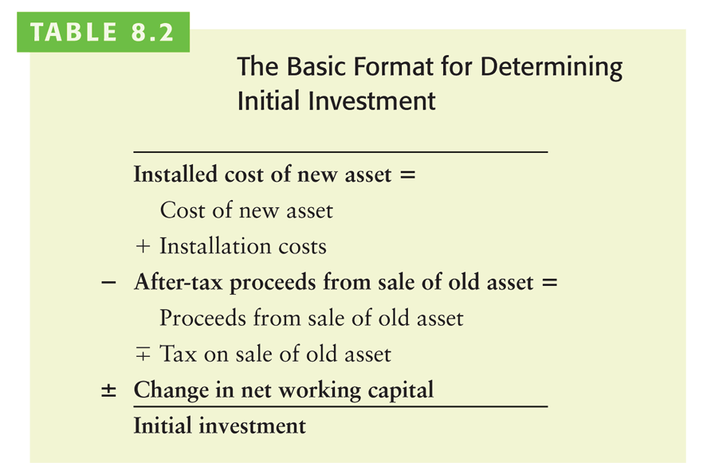

Or,
NINV = Cost + Installation + Shipping - After-Tax Salvage Value of the Old Asset
+ Changes in Net Working Capital (NWC) Requirement

Explanation of the Formula: (The equation above is similar to the one on page 305 in the book, but the order of the terms listed here is of a little difference. Also note that this formula is very general; a particular term on the right-hand side is included in the calculation ONLY IF its relevant information is provided in the project!!)
- Cost: The most basic piece of an initial investment (NINV). It equals to the total value of new fixed assets to be purchased in the project. If the purchases continue more than one year, you would need to discount them back to the present, and use the total present value for this term.

- Installation and Shipping: If the new purchased fixed asset has installation and shipping costs separately listed, they should be counted as part of the overall cost of the fixed asset, and included in the NINV formula.

- After-Tax Salvage Value: It will be in the formula, ONLY WHEN running the new project needs to sell some old existing fixed asset such as equipments the company is currently using. To find the after-tax salvage value, you need to use another formula which is :

After-Tax Salvage Value
= Salvage Value – (Salvage Value - Book Value of the Old Asset) * Tax Rate

Book Value of a Fixed Asset
= Initial total cost – cumulative depreciation until that day
Salvage value here refers to the market value of the old asset which is going to be disposed at the beginning of the project. Regardless transaction costs, salvage value can also be interpreted as ‘Proceeds from Sale of the Old Asset’. Book value is the ending balance of the asset on the balance sheet. If the market value of the old asset DIFFERS from its book value, there will be capital gain tax paid or tax shield on their difference.

To get the book value of an existing asset, you need to take the accumulated depreciations over the past years, subtract it from its original book value at purchase. (Refer to the second sample project later in the notes.)

- Changes in NWC Requirement: It appears in the formula ONLY IF the project mentions. Usually, before starting a new project, a company would have prepared some additional amount of working capital such as changes in inventories, cash, or accounts payable. If there is an initial net working capital requirement asked in the project, it is deemed as an extra amount of investment, and needs to be added into NINV calculation.

At year 1 to year N-1: Operating cash flow
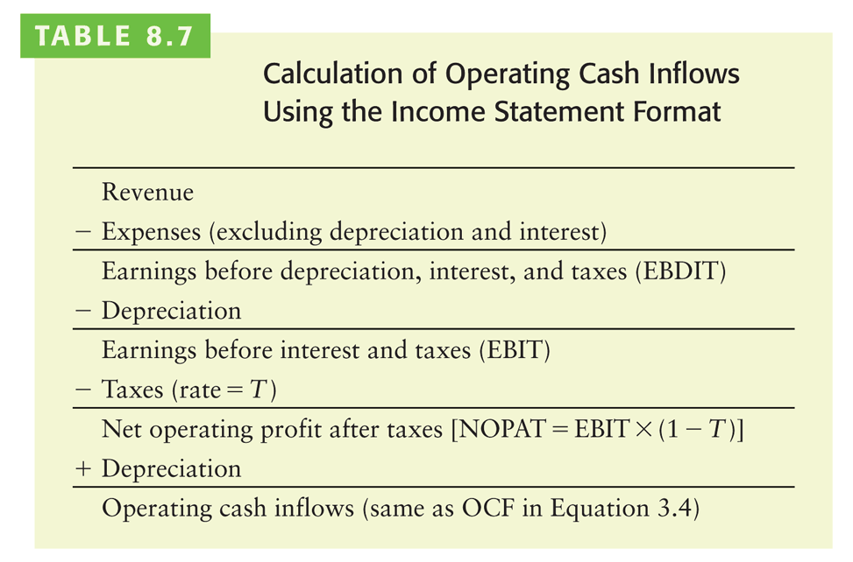
Also on pgs 109-111 in Chapter 3

Operating cash flow at each operating year is the net annual cash payoff of the project. It is calculated as

For those who are good at accounting, you may find that the calculation of NCF is slightly different from the routine calculation of operating cash flow for the entire company. First, changes in interest payments are excluded.

Ending year (N): Terminal cash flow

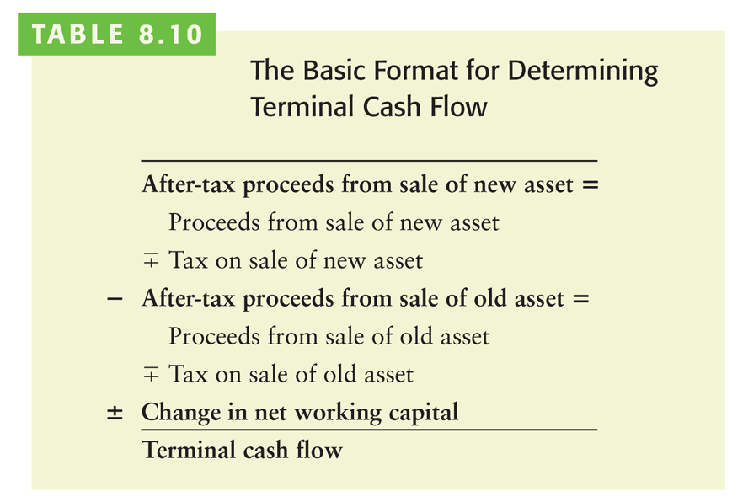
!! If the project is still operating in its terminal year, the operating cash flow generated in that year SHOULD also be an addition to the value of terminal cash flow.
This is the situation of this example. !!!
Or in a different format with one more item added in:

Terminal Cash Flow
= Operating Cash Flow in that yr + After-tax Proceeds (Salvage Value) of New Assets
- After-tax Proceeds (Salvage Value) of New Assets
+Recovery of Total Amount of NWC Invested in Previous Years

- The first term is NOT included in the formula table from our book. However, if a project still generates revenue during the terminal year, its operating cash flow MUST be counted in the calculation.
- The second to forth terms in the formula are included in calculation ONLY IF the project mentions. You may end up with a simpler calculation formula.
- After-tax Proceeds (or Salvage Value) of New Assets: When a project is ending, the fixed assets that were bought at the beginning and usable only in this project, need to be disposed. The proceeds from sale of these assets are added as an incremental cash inflow.
- After-tax Proceeds (or Salvage Value) of Old Assets: If the old assets had not been sold at the beginning of the project, they would be able to be sold at the end. Since the project has decided to sell them and receive the proceeds of sale at the beginning, the process of sales of the same assets at the ending time can NOT be earned. This is a choice of the timing of the sale. The forsaken after-tax proceeds of old assets here is used as a measure of the opportunity cost of this timing choice.
- Recovery of Total Amount of NWC being invested in the project: When a project ends, its requirement on the amount of NWC will be void. If there are NWC requirements mentioned the project, its total dollar amount shall be fully recovered at the end of the project. This is deemed as a saving, or cash inflow.

Example:
Exxon Mobil Co. plans to open a gas station beside Dowling Rudolph Campus since there are more students attending school now. The station is going to run for 4 years, and then they will sell it to a local company.
Given the information below, recognize the incremental cash flows at each year, put Y if the item is an incremental cash flow, or N if it is not.
Items | Cost or Revenue | Incremental cash flow? (Y/N)
Initial time (year 0)
Market research | $ 2,000
Station construction | $ 25,000
Equipment purchase | $ 350,000
Equipments installation | $ 10,000
Operating years (year 1 to year 4)
Annual Revenue (sales) | $ 85,000
Annual Cost | $ 14,000
Annual Depreciation | $ 60,000
Interest payment | $ 1,200
Tax rate | 40%
Terminal time (year 4)
Station after-tax sale | $ 270,000
Annual Revenue | $ 85,000
Annual Cost | $ 14,000
Annual Depreciation | $ 60,000
Interest payment | $ 1,200

Remove the items that do not belong to incremental CF, the information are shown as follows:
Items | Cost or Revenue
Initial time (year 0)
Station construction | $ 25,000
Equipment purchase | $ 350,000
Equipments installation | $ 10,000
Operating years (year 1 to year 4)
Annual Revenue (sales) | $ 85,000
Annual Cost | $ 14,000
Annual Depreciation | $ 60,000
Tax rate | 40%
Terminal time (year 4)
Station after-tax sale | $ 270,000
Annual Revenue | $ 85,000
Annual Cost | $ 14,000
Annual Depreciation | $ 60,000

Step 1: Calculate the initial year’s cash flow (‘initial investment’)

Analysis:
Installed cost of new asset means the TOTAL costs of every asset required in the project. There are three detailed costs described in this example that needs be summed up. The sum will be recorded as the book value of the assets on balance sheet.
Since there is no old asset existing before the gas station project started, the first item of the formula is zero;
There is no information about changes in working capital, so that item is also ignored.
Items | Value
Initial time (year 0)
Installed cost of new asset =
Station construction | $ 25,000
+ Equipment purchase | $ 350,000
+ Equipments installation | $ 10,000
– After-tax proceeds from the sale of old asset =
Proceeds from the sale | ---
+ Tax rate * ( Proceeds – Old asset book value)
+/– Change in net working capital | ---
= Initial investment

Step 2: Calculate the cash flow in each of the operating years (year 1- year 3)
Analysis:
This project generates constant annual revenue, costs and depreciation. Following the formula above, the operating cash flow in each of the operating year should be calculated, the value should be also no change over the three years.
Calculate Cash Flow in Year 1:
Name | Value
Revenue (sales) | $ 85,000
– Expenses (excl. depr.) | $ 14,000
= EBDIT (or Gross Profit)
– Depreciation | $ 60,000
= EBIT (or Operating Profit)
– Tax (40%)
= NOPAT (or Net Profit)
+ Depreciation | $ 60,000
= Operating Cash Flow
Cash Flow in Year 2:
Same as the value in year 1
Cash Flow in Year 3:
Same as the value in year 1

Step 3: Calculate the terminal cash flow at the end of the project (Year 4)
Analysis:
The project still generates revenue in year 4, so the value of operating cash flow should be calculated;
There is only the sale of the station, which is the NEW ASSET bought AFTER/AT the beginning of the project, so the after-tax proceeds from sale of new asset should be added in;
There is NO sale of old asset. The asset bought and existed BEFORE the beginning of the project, so this item value is zero.
No information on the change in net working capital, this item is zero.
1) Calculate Operating Cash Flow (OCF) in Year 4:
Name | Value
Revenue (sales)
– Expenses (excl. depr.)
= EBDIT (or Gross Profit)
– Depreciation
= EBIT (or Operating Profit)
– Tax (40%)
= NOPAT (or Net Profit)
+ Depreciation
= Operating Cash Flow
2) Calculate Terminal Cash Flow
Items | Value
After-tax proceeds from the sale of new asset = | $ 270,000
Proceeds from the sale
- Tax rate * ( Proceeds – New asset book value)
– After-tax proceeds from the sale of old asset =
Proceeds from the sale | ---
- Tax rate * ( Proceeds – Old asset book value)
+/– Change in net working capital | ---
= Terminal cash flow

Sum up annual incremental cash flow:
 | Year 0 | Year 1 | Year 2 | Year 3 | Year 4
Cashflow | $ | $ | $ | $ | $
Example 2: A Replacement Project (complicated but important!!)

Degnan Dance Company, Inc., a manufacturer of dance and exercise apparel, is considering replacing an existing piece of equipment with a more sophisticated machine. The following information is given.
Facts
Existing Machine | Proposed Machine
Cost = $100,000 | Cost = $150,000
Purchased 2 years ago | Installation = $20,000
Depreciation using MACRS over 5-year recovery schedule | Depreciation—the MACRS a 5-year recovery schedule
Current market value = $105,000
Five year usable life remaining | Five years usable life expected
Market value after 5 years = 0 | Market value after 5 years = $10,000

Revenues and Expenses (excl. depreciation and interest)
Existing Machine |  |  |  | Proposed Machine
 |  | Revenue | Expenses |  |  | Revenue | Expenses
Year | 1 | $280,000 | 110,000 | Year | 1 | $320,000 | 150,000
 | 2 | 300,000 | 110,000 |  | 2 | 350,000 | 150,000
 | 3 | 200,000 | 110,000 |  | 3 | 350,000 | 150,000
 | 4 | 340,000 | 110,000 |  | 4 | 350,000 | 150,000
 | 5 | 280,000 | 110,000 |  | 5 | 300,000 | 150,000

MACRS 5-year recovery schedule
Year | Dep. Percentage
1 | 20%
2 | 32%
3 | 19%
4 | 12%
5 | 12%
6 | 5%

The firm pays 40% taxes on ordinary income and capital gains.

1. What is the initial investment?

Analysis:

Information that is given__

Items that need to be calculated__

1) Calculate the book value of the existing asset being replaced.

Annual Depreciation = cost of fixed asset * depreciation rate

Year | Total Cost | * % Depreciation | = Annual Depreciation
1 | $ 100,000 | 20% | $ 20,000
2 | $ 100,000 | 32%
3 | $ 100,000 | 19%
4 | $ 100,000 | 12%
5 | $ 100,000 | 12%
6 | $ 100,000 | 5%

Book value of fixed asset = Cost of fixed asset – accumulated depreciation

The equipment was bought 2 years ago, so the first two years’ depreciations have already been taken before starting the replacement project.

Book value = Cost – Dep. at year1 – Dep. at year 2

=

2) Calculate the after-tax proceeds from the sale of the existing asset.

Tax payment = ( market selling price – book value ) * tax rate

=

After-tax value = market selling price – tax payment

=

3) Calculate the initial investment required for the new asset.
Items | Value
Initial time (year 0)
Installed cost of new asset =
+ Equipment purchase
+ Equipments installation
– After-tax proceeds from the sale of old asset =
Proceeds from the sale
- Tax rate * ( Proceeds – Old asset book value)
+/– Change in net working capital
= Initial investment

2. What are the incremental cash flows from year 1 to year 5?

Analysis:

Information that is given__

Items that need to be calculated__

1) Find the annual depreciation of the proposed machine

Annual Depreciation = cost of fixed asset * depreciation rate
Year | Total Cost | * % Depreciation | = Annual Depreciation
1 | $ 170,000 | 20% | $ 34,000
2 | $ 170,000 | 32%
3 | $ 170,000 | 19%
4 | $ 170,000 | 12%
5 | $ 170,000 | 12%
6 | $ 170,000 | 5%

(Note the cost of the proposed machine is the sum of the purchase price and the installation fee. That is the total cost!!)

2) Calculate Operating Cash Flows

Analysis (important)

The beginning of the replacement project is in the third year of the existing machine and the first year of the proposed new machine. Therefore, the depreciation percentage used for the three year old existing machine should be the rate of 5-year MACRS at the 3rd year, which is 19%!!
Formula
Revenue (sales)
– Expenses (excl. depr.)
= EBDIT (or Gross Profit)
– Depreciation
= EBIT (or Operating Profit)
– Tax (40%)
= NOPAT (or Net Profit)
+ Depreciation
= Operating Cash Flow

Yr | (1)  Revenue | (2) Expenses | (3)  Dep. | (4) = (1)- (2)-(3)  EBIT | (5)=(4)*0.4  Taxes | (6)=(4)-(5) Net Profit | (7)=(6)+(3)  Cash Flow
Existing Machine
1 | 280,000 | 110,000
2 | 300,000 | 110,000
3 | 200,000 | 110,000
4 | 340,000 | 110,000
5 | 280,000 | 110,000
Proposed Machine
1 | 320,000 | 150,000
2 | 350,000 | 150,000
3 | 350,000 | 150,000
4 | 350,000 | 150,000
5 | 300,000 | 150,000

3) Calculate Incremental Cash Flows for Replacement Projects
Year | Proposed | - | Existing | = | Incremental
1
2
3
4
5

3. What is the terminal cash flow at the end of year 5 ?
Analysis:

Information that is given__

Items that need to be calculated__

1) Calculate the after-tax value of the sale of proposed machine

Book value of fixed aset = Cost of fixed asset – accumulated depreciation
book value of proposed machine after 5 years’ depreciation
= Cost - 5 years’ depreciation
=

Tax payment = ( market selling price – book value ) * tax rate
=
After-tax value of the sale of = market price - tax
=

2) Calculate the terminal cash flow
Terminal cash flow = operating cash flow at year 5
+ after-tax value of proposed new machine
=

4. Summarize the project incremental cash flows
 | Initial | Yr 1 | Year 2 | Year 3 | Year 4 | Year 5
Cash flow

