Bond Valuation
Learning Goals
Required calculations:
- bond price, yield to maturity, current yield ,(yield to call)
Required concepts:
- Bond indenture, call feature, sinking fund provision, bond types, yield to maturity, current yield, coupon rate, discount bond, premium bond and par value, and interest rate risk;
Required understandings:
- The relationship between bond price and coupon rate, yield, time to maturity. (price sensitivity), the relationship between coupon rate and yield to maturity.
Outline:
1. Bond Basic
2. Bond Provisions
3. Bond Types
4. Bond Valuation
5. Important Relationships
6. Current Yield

1. Bond Basic Information
- A bond is a long-term debt instrument that pays bondholders a specified amount of periodic interest rate over a specified period of time.
- A bond’s principal (or par value) is the amount owed by the company to bondholders on the maturity date.
- A bond’s maturity date is the time at which the bond expires and its principal must be completely repaid.
- A bond’s time to maturity is the time left until maturity date. It is a key input of bond valuation.
- A bond’s coupon rate is the specified interest rate that must be periodically paid to bondholders. It is usually fixed over the life of a bond.
  - The dollar value of coupon payment in each period is an annuity cash inflow to bondholders, and is the input of PMT in bond valuation.
- A bond’s yield-to-maturity (YTM) is the implied rate of return on a bond calculated from bond price. It varies with the bond’s market price over the life of the bond. It is the discount rate (I/YR) in bond valuation. YTM is often called as required rate of return, market interest rate on similar bonds, discount rate, etc.
- A bond’s current yield is an alternative but rough measure of rate of return. It equals to the annual coupon payment divided by the current bond price.
- Both types of yield move negatively with bond prices, i.e. when bond price increases, bond yield declines, and vice versa.

2. Bond Indenture and Provisions
Bond indenture is a legal document that specifies the rights of the bondholders and the duties of the issuing corporation. It includes standard and special debt provisions.
- Call provision _ It benefits bond issuers.
- Call provision gives the issuer the right to retire its existing bond before maturity.
- Bond issuers will exercise this right when market interest rate drops significantly below the coupon rates of its existing bonds. And then, they can refinance their debts by issuing a new bond with similar terms as the called one, with a lower coupon rate.
- When a bond is called, its price is usually sold at premium (above its par value). Once a bond is called, investors will receive their principals plus an additional amount of money as a compensation which is named ‘call premium’. Call premium is normally around 10% of the par value. Even with the additional amount of the call premium, the existing bondholders will still get hurt by the call, for they can no longer receive high coupon incomes in the months to come.
- In order to protect the investors of a new issue, most bonds have a deferred call provision.

- Sinking fund provision_ It reduces default risk but rises up call risk.
- It is a restrictive provision that requires a bond issuer to pay off a loan over its life rather than all at maturity.
- It is similar to amortization on a term loan.
- Sinking funds are generally handled in 2 ways:
  - Call x% at par per year for sinking fund purposes.
  - Buy bonds on open market.
Company would call if market rate is below the coupon rate and bond sells at a premium. Use open market purchase if market rate is above coupon rate and bond sells at a discount.

Pros and Cons
- It reduces the risk of defaults on a bond and protects investors.
- It can shorten a bond’s average maturity.
- It is not good for investors if market rate declines and the bond is callable. Because the issuer will have funding available to retire its existing high coupon bond and replace it by a low interest bond.

- Other restrictive covenants protecting investors.
Restrictive debt provisions are contractual clauses that place operating and financial constraints on the borrower, such as:
  - Minimum equity levels
  - Prohibition against factoring receivables
  - Fixed asset restrictions
  - Constraints on subsequent borrowing
  - Limitations on cash dividends.

- Others important terms affecting a bond’s value:
  - Is the bond a secured or unsecured debt?
  - Is the bond a senior or subordinated debt?
  - Does the bond have collaterals (security) pledged against it?
  - Is the bond combined with convertible provision or warrants?
Information about the first three questions above describes the level of default risk on a bond. A secured bond, a senior bond, or a bond backed by collaterals has lower default risk; therefore, has lower yield (return) and higher market price.
A bond with convertible provision or warrants is intended to increase its attraction to investors by providing additional options or values.

- Bond Ratings
In order to provide investors with a better guidance of their bond issues, issuing companies hire ratings companies such as Moody’s, S&P and Fitch to put a rating grade on each of its bonds. The rating will be updated periodically or upon big events. There are two groups of rating grades: investment grade (BBB or above) and speculative grade (below BBB).
What factors affect default risk and bond ratings?
Financial performance: debt ratio, coverage ratios, such as interest coverage ratio or EBITDA coverage ratio, and current ratios.

3. Bond Types
By issuer
a. government bonds e.g. US Treasury, federal agency, state, local
b. corporate bonds e.g. industrial, utility, financial, transportation
c. international bonds e.g. foreign government, foreign corporation,
By security
a. unsecured debt - backed by faith in the taxing power of the government, or the good name of the company (debenture)
b. secured debt e.g. revenue bond, assessment bond, mortgage bond, collateral trust bond, equipment trust certificate
Bond security sometimes comes from non-traditional sources. Ex., some rock stars floated bonds using their future earnings as backing.
By term
a. short-term : original maturity ≤ 1 year e.g. Treasury bills
b. intermediate-term: original maturity > 1 years & < 10 years
e.g. US Treasury notes
c. long-term : original maturity ≥ 10 years e.g. Treasury bonds
By cash flows
- Coupon bonds – pay interests periodically over the life of the bonds
- Zero coupon bonds – sell at deep discount and repay the par value at maturity, no direct interest payment, but interest earned by
- Variable (adjustable) rate - the rate fluctuates in accordance with some market index or predetermined schedule
- Inflation-indexed Treasury bonds – the principal value is adjusted based on the consumer price index
By price
Discount bonds – with bond prices below their par value (principal)
Premium bonds – with bond prices above their par value (principal)
Par bonds – with bond prices equals to their par value (principal)

4. Bond Valuation
- In an efficient market, the market value of an asset or investment equals to its market price in a long run. Using this logic, economists use the calculation of market value of an asset to predict its price.
- The market value of an asset is the total present value (PV) of all future cash flows expected to be received from the asset. Therefore, a bond’s value (true price) is equivalent to the total PV of its coupon payments and principal.
Value of bond = PV of coupon payments + PV of principal
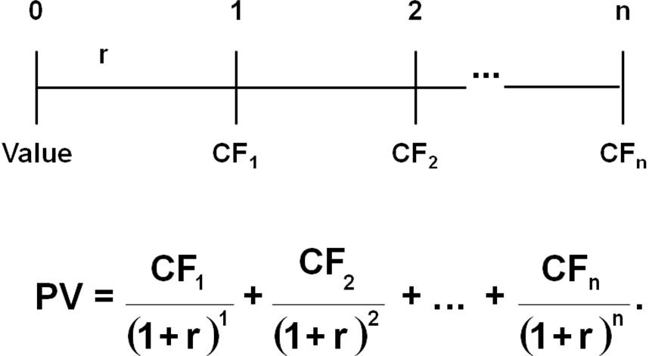

Calculations
There are five components in bond valuations: n, r, coupon payment(INT), bond price(PV) and principal. For each calculation, the information on four of the components will be given and used as the inputs; then the fifth one is to be computed.

I. Finding Bond Prices
1) The bond consists of a 10-year, 10% required return, with $100 annual coupon plus a $1,000 principal at year 10.

Conclusion: IF YTM = Coupon Rate,

2) What would happen if expected inflation rose by 3%, causing required return equaled to 13%?

Conclusion: IF YTM > Coupon Rate,

3) What would happen if inflation fell, and the required return declined to 7%?

Conclusion: IF YTM < Coupon Rate,

4) If the bond in question 3) is paying its coupon semiannually, that is to pay twice a year with a half amount of annual payment at each time, what will happen to the bond price? (The required return is 7% from question 3). )

With semiannual payment schedule, the bond will be ______valuable.
!!!Note: Most of corporate bonds are paying interest semiannually. When you are dealing with a semiannual coupon bond, you must make three adjustments in the calculation: n, r, and INT.

II. Finding Bond’s Yield to Maturity (YTM):
Given bond price (PV) to find the implied promised return (r). Without a financial calculator, you can use trial and error method to find the value.
1) What is the YTM on a 10-year, 9% annual coupon, $1,000 par value bond selling for $850?

2) What is the bond’s YTM if the price rose to $1,200?

III. Find Bond’s Yield to Call (YTC):
Similar to the calculation of yield to maturity, but the differences are the input value for n and the final payment. The n will represent the number of the coupon payments before the bond’s first call time. The final payment will not be the principal but the amount of call price that bond investors will receive when the bond is called.
Example: What is the YTC on a 10-year, 9% annual coupon, $1,000 par value bond selling for $1200? If the call price is $1090, and the first call time will be 5 years from now.

5. Important Bond Relationship!!
Between yield and coupon:
IF Bond Price < $1000 YTM > Coupon Rate
IF Bond Price > $1000 YTM < Coupon Rate
IF Bond Price = $1000 YTM = Coupon Rate
Between bond price and yield:
The higher the yield, the higher the cost of investing a bond; therefore, the lower the bond’s value or price
Between bond price and coupon rate:
The lower the coupon rate, the lower the value of the bond
Between time to maturity and bond price sensitivity
The longer the term, the higher the sensitivity of bond prices to the changes in market interest rate. This sensitivity can also be explained as Interest rate risk. The longer the time to maturity, the higher the interest rate risk the bondholders need to face. For example:
Interest rate
1-yr bond
% Change
10-yr bond
Change
5%
$1,048
$1,386
10%
1,000
4.8%
1,000
38.6%
15%
956
4.4%
749
25.1%
With 5% change in interest rate level, the percentage of change in the prices of the 1-year bond is much lighter than those in the 10-year bond. The wider the variation, the greater its interest rate risk is.

6. A Rough Measure_ Current Yield
Current Yield measures the annual return to an investor based on the current price.
Current = Annual Coupon Payment
Yield Current Market Price
For example, a 10% coupon bond which is currently selling at $1,150 would have a current yield of:
Current Yield = $100 / $1,150 = 8.7%

7. Compare different return measures:
Features | Coupon rate | Current yield | Yield to maturity
Fixed or changing?
How to calculate?
Usage in bond valuation
A discount bond
A premium bond
A par bond

